|  |
| --- |
| Photo displaying partial image of two pie charts on a canvas-textured page |
| Github Projects  DXC TECHNOLOGY |
| |  |  |  | | --- | --- | --- | | Dell |  | [Course title] | |

Participant Name: **Atharva Shivaji Jadhav**

Employee id:

Project: **DP-203 GitHub project**

**Module1:**

Explore compute and storage options for data engineering workloads

**Lab 1 - Delta Lake architecture**

Task 1: Create and configure the Azure Databricks workspace

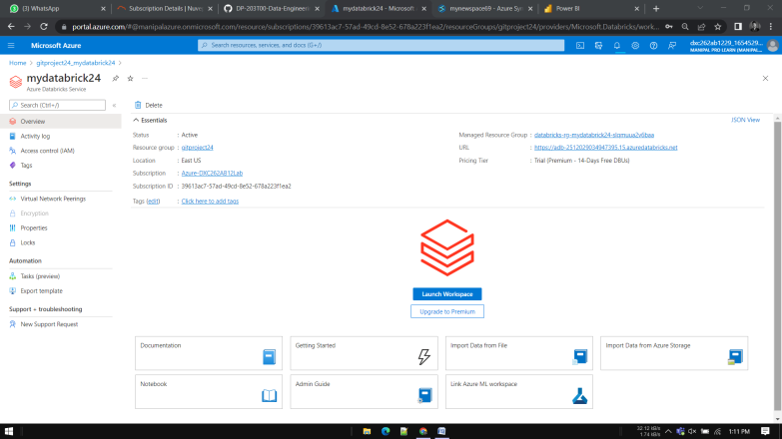

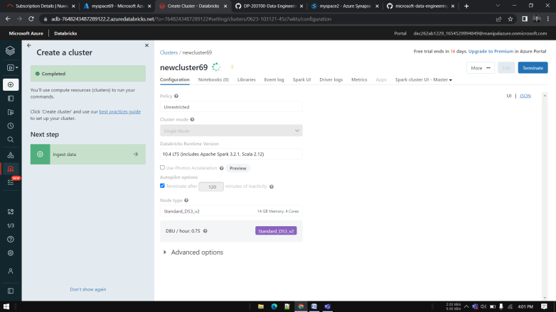

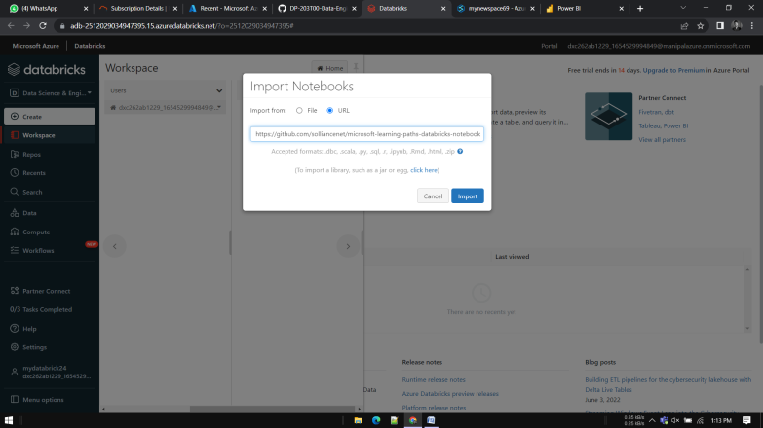

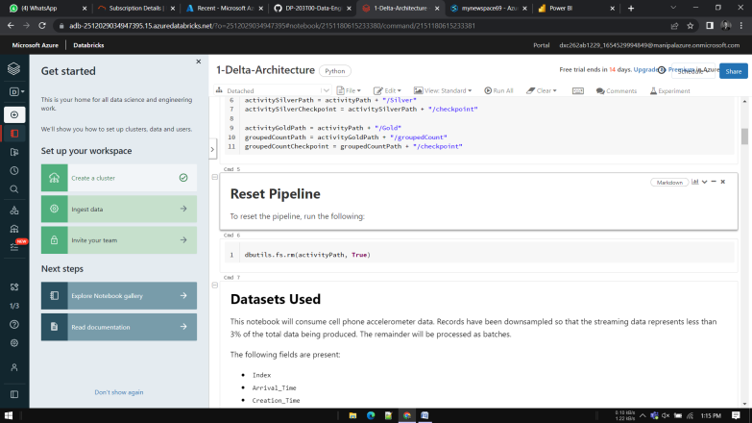

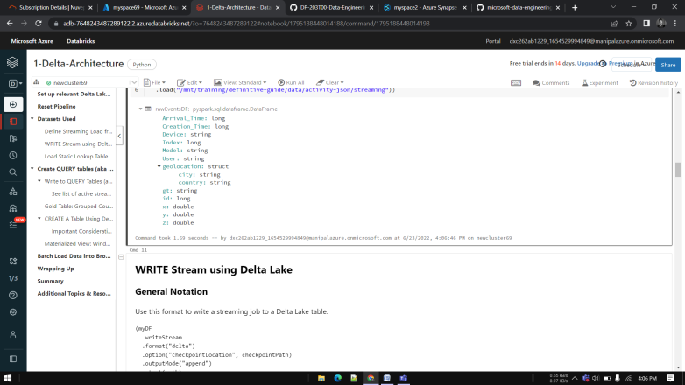

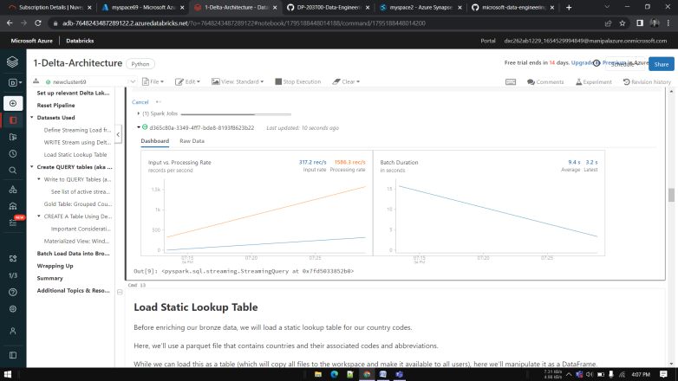

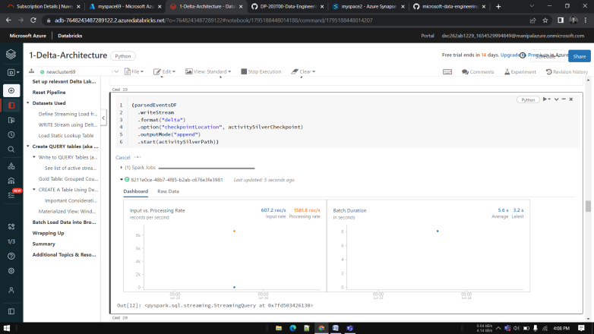

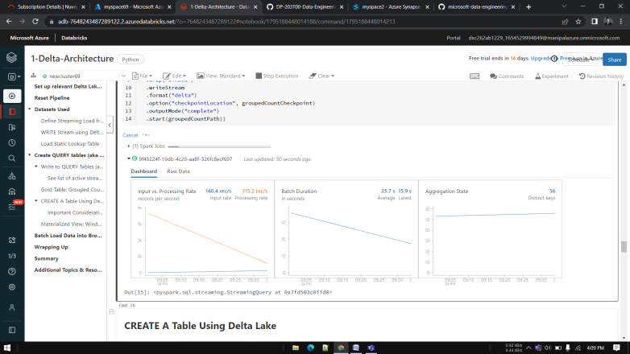

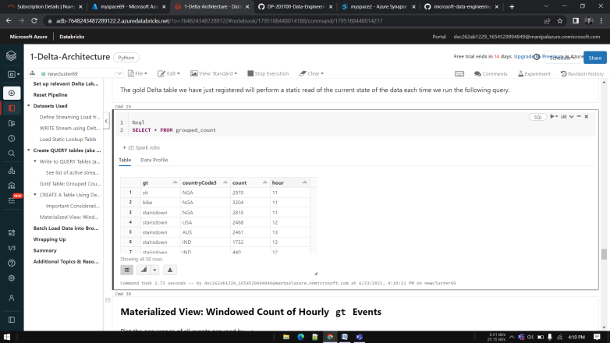

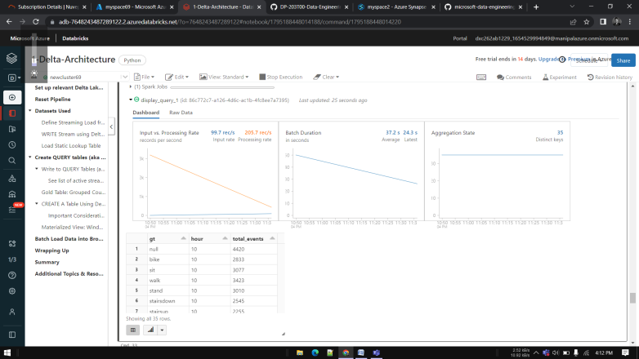

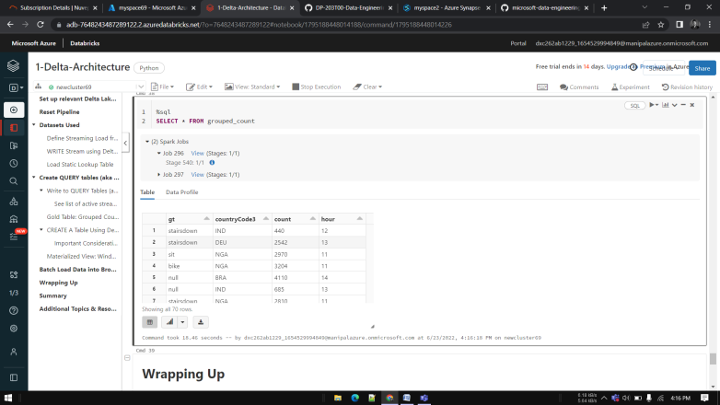

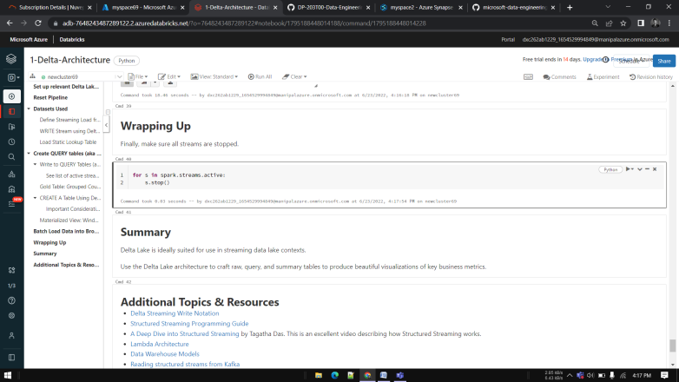

**Lab 2 - Working with Apache Spark in Synapse Analytics**

Exercise 1: Load and data with Spark

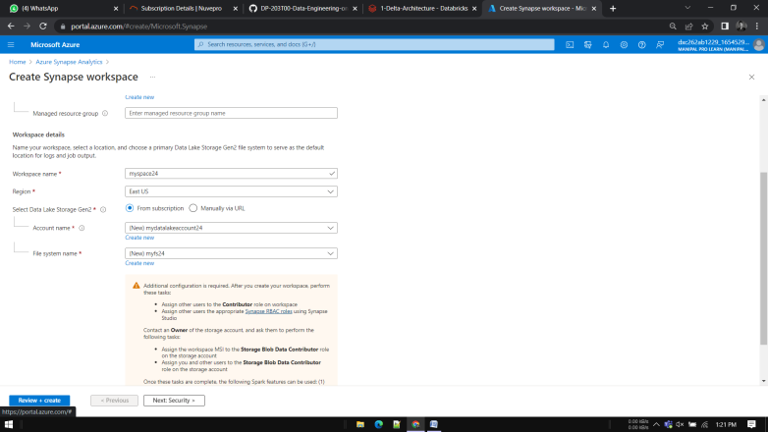

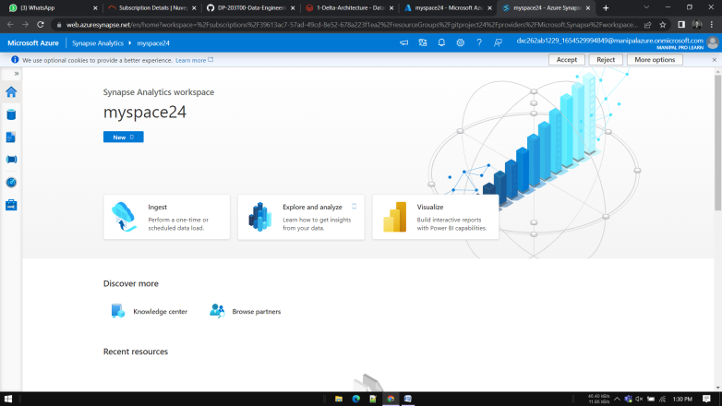

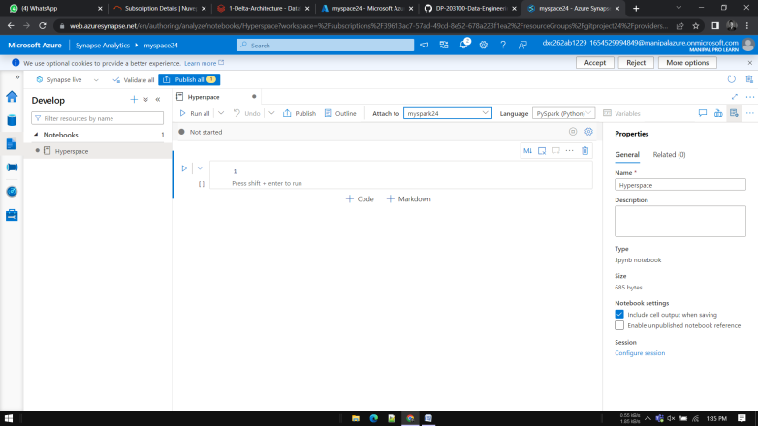

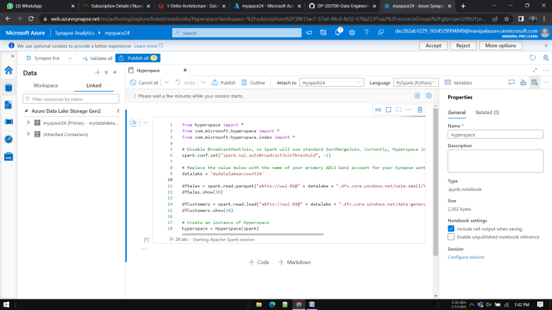

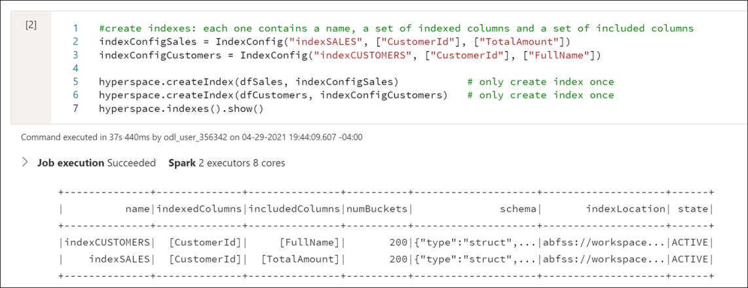

**Lab 2:**

**Module1:** **- Design and Implement the serving layer**

Start the dedicated SQL pool

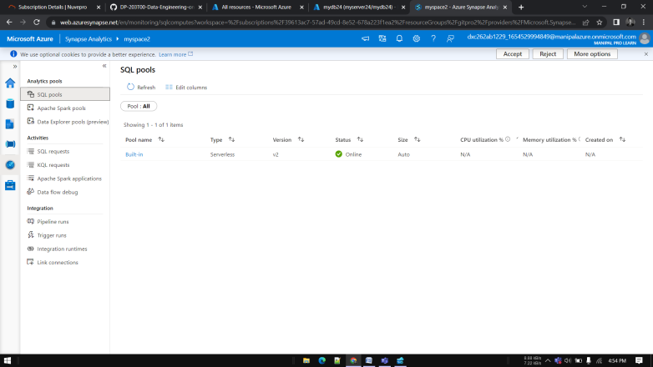

Open the resource group for this lab, then select the **SourceDB** SQL database

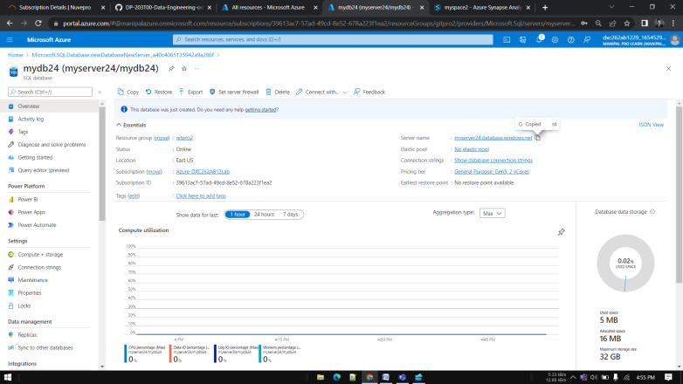

Copy the Server name value on the Overview pane.

Open Azure Data Studio.

Select Servers on the left-hand menu, then click Add Connection.

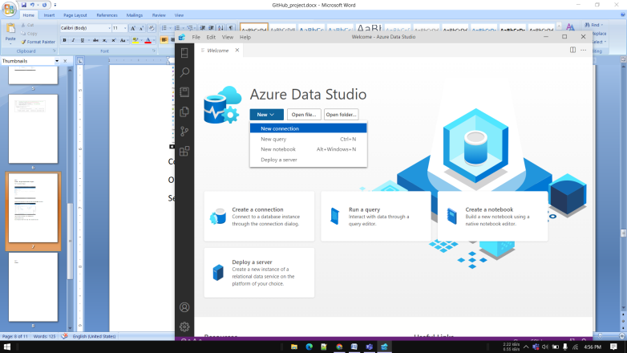

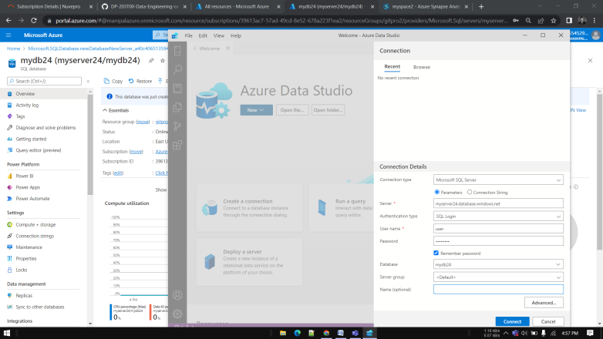

Select Servers in the left-hand menu, then right-click the SQL server you added at the beginning of the lab. Select New Query.

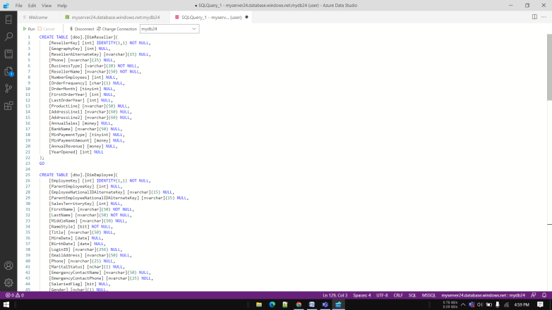

CREATE TABLE [dbo].[DimReseller](

    [ResellerKey] [int] IDENTITY(1,1) NOT NULL,

    [GeographyKey] [int] NULL,

    [ResellerAlternateKey] [nvarchar](15) NULL,

    [Phone] [nvarchar](25) NULL,

    [BusinessType] [varchar](20) NOT NULL,

    [ResellerName] [nvarchar](50) NOT NULL,

    [NumberEmployees] [int] NULL,

    [OrderFrequency] [char](1) NULL,

    [OrderMonth] [tinyint] NULL,

    [FirstOrderYear] [int] NULL,

    [LastOrderYear] [int] NULL,

    [ProductLine] [nvarchar](50) NULL,

    [AddressLine1] [nvarchar](60) NULL,

    [AddressLine2] [nvarchar](60) NULL,

    [AnnualSales] [money] NULL,

    [BankName] [nvarchar](50) NULL,

    [MinPaymentType] [tinyint] NULL,

    [MinPaymentAmount] [money] NULL,

    [AnnualRevenue] [money] NULL,

    [YearOpened] [int] NULL

);

GO

CREATE TABLE [dbo].[DimEmployee](

    [EmployeeKey] [int] IDENTITY(1,1) NOT NULL,

    [ParentEmployeeKey] [int] NULL,

    [EmployeeNationalIDAlternateKey] [nvarchar](15) NULL,

    [ParentEmployeeNationalIDAlternateKey] [nvarchar](15) NULL,

    [SalesTerritoryKey] [int] NULL,

    [FirstName] [nvarchar](50) NOT NULL,

    [LastName] [nvarchar](50) NOT NULL,

    [MiddleName] [nvarchar](50) NULL,

    [NameStyle] [bit] NOT NULL,

    [Title] [nvarchar](50) NULL,

    [HireDate] [date] NULL,

    [BirthDate] [date] NULL,

    [LoginID] [nvarchar](256) NULL,

    [EmailAddress] [nvarchar](50) NULL,

    [Phone] [nvarchar](25) NULL,

    [MaritalStatus] [nchar](1) NULL,

    [EmergencyContactName] [nvarchar](50) NULL,

    [EmergencyContactPhone] [nvarchar](25) NULL,

    [SalariedFlag] [bit] NULL,

    [Gender] [nchar](1) NULL,

    [PayFrequency] [tinyint] NULL,

    [BaseRate] [money] NULL,

    [VacationHours] [smallint] NULL,

    [SickLeaveHours] [smallint] NULL,

    [CurrentFlag] [bit] NOT NULL,

    [SalesPersonFlag] [bit] NOT NULL,

    [DepartmentName] [nvarchar](50) NULL,

    [StartDate] [date] NULL,

    [EndDate] [date] NULL,

    [Status] [nvarchar](50) NULL,

    [EmployeePhoto] [varbinary](max) NULL

);

GO

CREATE TABLE [dbo].[DimProduct](

    [ProductKey] [int] IDENTITY(1,1) NOT NULL,

    [ProductAlternateKey] [nvarchar](25) NULL,

    [ProductSubcategoryKey] [int] NULL,

    [WeightUnitMeasureCode] [nchar](3) NULL,

    [SizeUnitMeasureCode] [nchar](3) NULL,

    [EnglishProductName] [nvarchar](50) NOT NULL,

    [SpanishProductName] [nvarchar](50) NOT NULL,

    [FrenchProductName] [nvarchar](50) NOT NULL,

    [StandardCost] [money] NULL,

    [FinishedGoodsFlag] [bit] NOT NULL,

    [Color] [nvarchar](15) NOT NULL,

    [SafetyStockLevel] [smallint] NULL,

    [ReorderPoint] [smallint] NULL,

    [ListPrice] [money] NULL,

    [Size] [nvarchar](50) NULL,

    [SizeRange] [nvarchar](50) NULL,

    [Weight] [float] NULL,

    [DaysToManufacture] [int] NULL,

    [ProductLine] [nchar](2) NULL,

    [DealerPrice] [money] NULL,

    [Class] [nchar](2) NULL,

    [Style] [nchar](2) NULL,

    [ModelName] [nvarchar](50) NULL,

    [LargePhoto] [varbinary](max) NULL,

    [EnglishDescription] [nvarchar](400) NULL,

    [FrenchDescription] [nvarchar](400) NULL,

    [ChineseDescription] [nvarchar](400) NULL,

    [ArabicDescription] [nvarchar](400) NULL,

    [HebrewDescription] [nvarchar](400) NULL,

    [ThaiDescription] [nvarchar](400) NULL,

    [GermanDescription] [nvarchar](400) NULL,

    [JapaneseDescription] [nvarchar](400) NULL,

    [TurkishDescription] [nvarchar](400) NULL,

    [StartDate] [datetime] NULL,

    [EndDate] [datetime] NULL,

    [Status] [nvarchar](7) NULL

);

GO

CREATE TABLE [dbo].[FactResellerSales](

    [ProductKey] [int] NOT NULL,

    [OrderDateKey] [int] NOT NULL,

    [DueDateKey] [int] NOT NULL,

    [ShipDateKey] [int] NOT NULL,

    [ResellerKey] [int] NOT NULL,

    [EmployeeKey] [int] NOT NULL,

    [PromotionKey] [int] NOT NULL,

    [CurrencyKey] [int] NOT NULL,

    [SalesTerritoryKey] [int] NOT NULL,

    [SalesOrderNumber] [nvarchar](20) NOT NULL,

    [SalesOrderLineNumber] [tinyint] NOT NULL,

    [RevisionNumber] [tinyint] NULL,

    [OrderQuantity] [smallint] NULL,

    [UnitPrice] [money] NULL,

    [ExtendedAmount] [money] NULL,

    [UnitPriceDiscountPct] [float] NULL,

    [DiscountAmount] [float] NULL,

    [ProductStandardCost] [money] NULL,

    [TotalProductCost] [money] NULL,

    [SalesAmount] [money] NULL,

    [TaxAmt] [money] NULL,

    [Freight] [money] NULL,

    [CarrierTrackingNumber] [nvarchar](25) NULL,

    [CustomerPONumber] [nvarchar](25) NULL,

    [OrderDate] [datetime] NULL,

    [DueDate] [datetime] NULL,

    [ShipDate] [datetime] NULL

);

GO

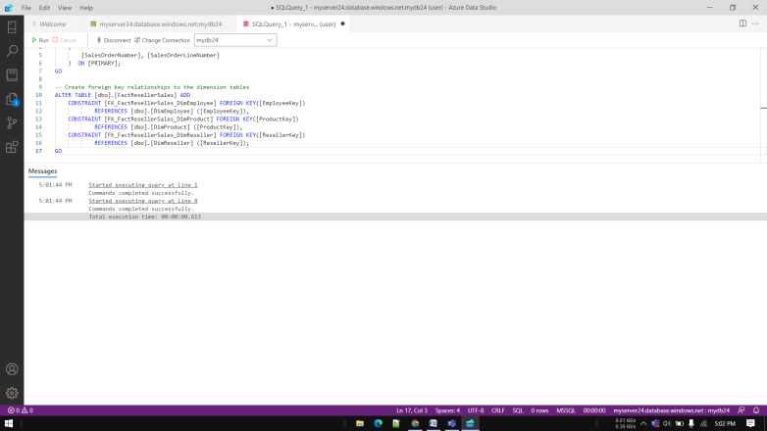

**Create product snowflake schema in SQL database**

In this task, you add two new dimension tables: DimProductCategory and DimProductSubcategory. You create a relationship between these two tables and the DimProduct table to create a normalized product dimension, known as a snowflake dimension. Doing so updates the star schema to include the normalized product dimension, transforming it into a snowflake schema.

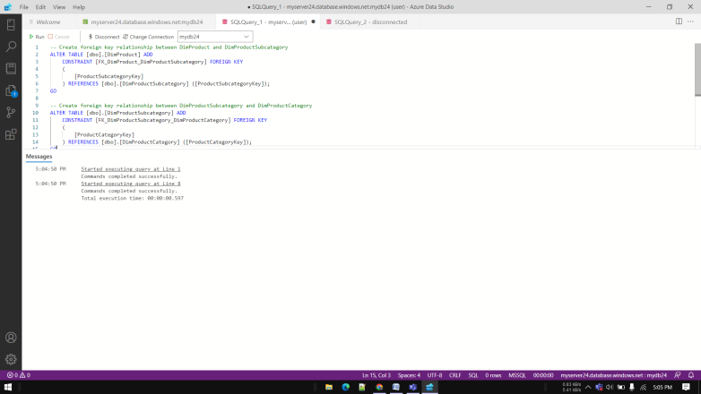

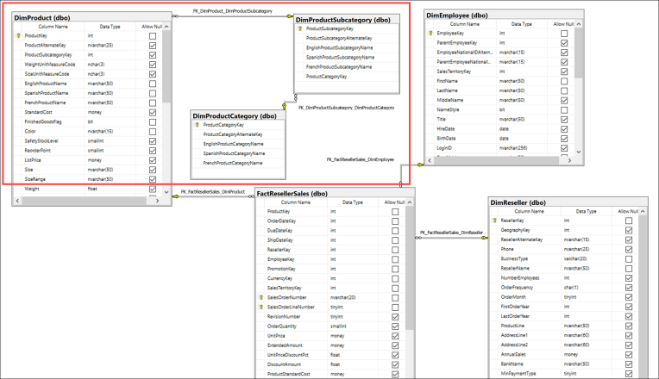

**Task 2: Create reseller snowflake schema in SQL database**

In this task, you add two new dimension tables: DimCustomer and DimGeography. You create a relationship between these two tables and the DimReseller table to create a normalized reseller dimension, or snowflake dimension.

CREATE TABLE [dbo].[DimCustomer](

    [CustomerKey] [int] IDENTITY(1,1) NOT NULL,

    [GeographyKey] [int] NULL,

    [CustomerAlternateKey] [nvarchar](15) NOT NULL,

    [Title] [nvarchar](8) NULL,

    [FirstName] [nvarchar](50) NULL,

    [MiddleName] [nvarchar](50) NULL,

    [LastName] [nvarchar](50) NULL,

    [NameStyle] [bit] NULL,

    [BirthDate] [date] NULL,

    [MaritalStatus] [nchar](1) NULL,

    [Suffix] [nvarchar](10) NULL,

    [Gender] [nvarchar](1) NULL,

    [EmailAddress] [nvarchar](50) NULL,

    [YearlyIncome] [money] NULL,

    [TotalChildren] [tinyint] NULL,

    [NumberChildrenAtHome] [tinyint] NULL,

    [EnglishEducation] [nvarchar](40) NULL,

    [SpanishEducation] [nvarchar](40) NULL,

    [FrenchEducation] [nvarchar](40) NULL,

    [EnglishOccupation] [nvarchar](100) NULL,

    [SpanishOccupation] [nvarchar](100) NULL,

    [FrenchOccupation] [nvarchar](100) NULL,

    [HouseOwnerFlag] [nchar](1) NULL,

    [NumberCarsOwned] [tinyint] NULL,

    [AddressLine1] [nvarchar](120) NULL,

    [AddressLine2] [nvarchar](120) NULL,

    [Phone] [nvarchar](20) NULL,

    [DateFirstPurchase] [date] NULL,

    [CommuteDistance] [nvarchar](15) NULL

);

GO

CREATE TABLE [dbo].[DimGeography](

    [GeographyKey] [int] IDENTITY(1,1) NOT NULL,

    [City] [nvarchar](30) NULL,

    [StateProvinceCode] [nvarchar](3) NULL,

    [StateProvinceName] [nvarchar](50) NULL,

    [CountryRegionCode] [nvarchar](3) NULL,

    [EnglishCountryRegionName] [nvarchar](50) NULL,

    [SpanishCountryRegionName] [nvarchar](50) NULL,

    [FrenchCountryRegionName] [nvarchar](50) NULL,

    [PostalCode] [nvarchar](15) NULL,

    [SalesTerritoryKey] [int] NULL,

    [IpAddressLocator] [nvarchar](15) NULL

);

GO

**3.Implementing a Time Dimension Table**

**Task 1: Create time dimension table**

CREATE TABLE DimDate

(DateKey int NOT NULL,

DateAltKey datetime NOT NULL,

CalendarYear int NOT NULL,

CalendarQuarter int NOT NULL,

MonthOfYear int NOT NULL,

[MonthName] nvarchar(15) NOT NULL,

[DayOfMonth] int NOT NULL,

[DayOfWeek] int NOT NULL,

[DayName] nvarchar(15) NOT NULL,

FiscalYear int NOT NULL,

FiscalQuarter int NOT NULL)

GO

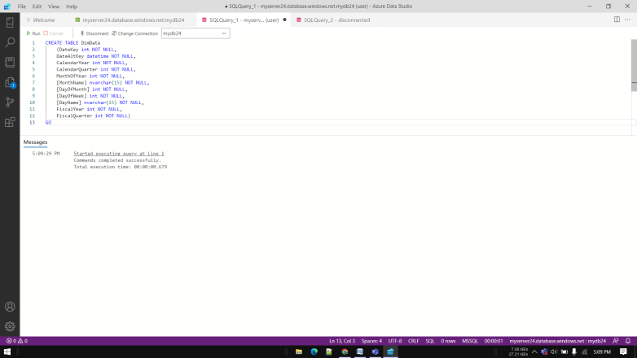

**Task 2: Populate the time dimension table**

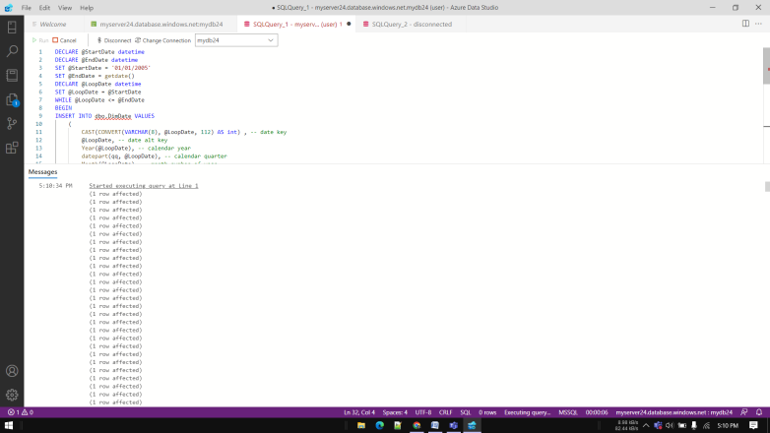

**SELECT * FROM dbo.DimDate**

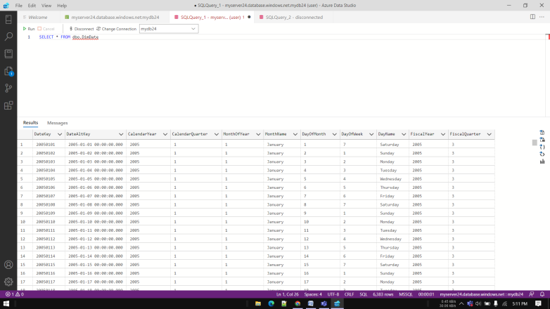

**Module6:**

**Data exploration and transformation in Azure Databricks**

**Lab 1 - Working with DataFrames**

Task 1 - Create and configure the Azure Databricks workspace

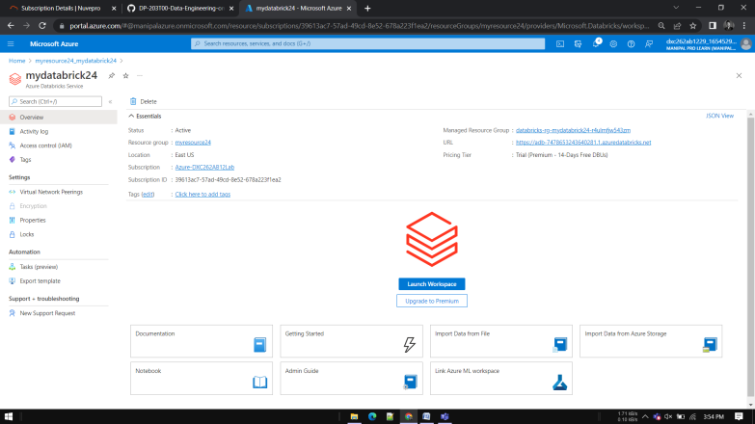

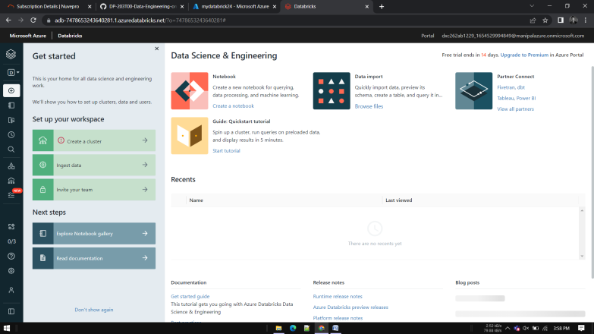

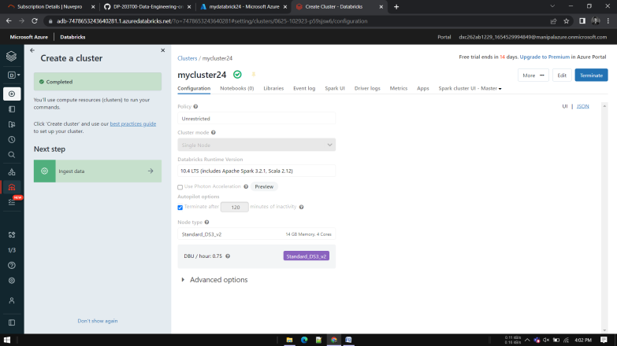

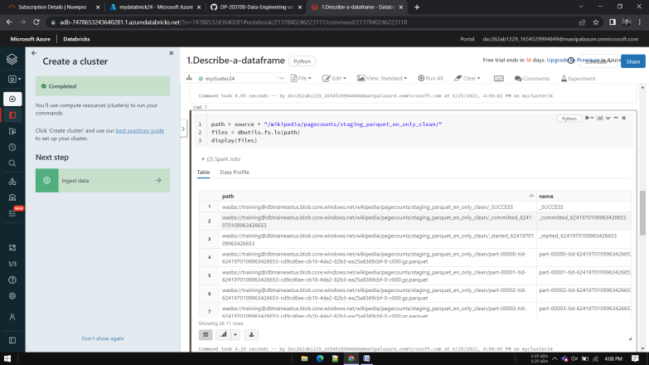

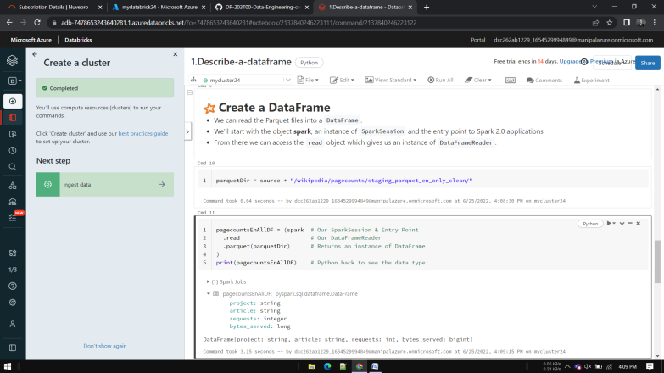

**2.Use-common-dataframe-methods**

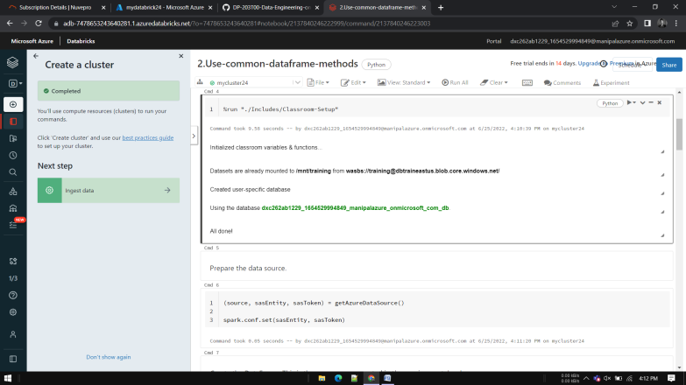

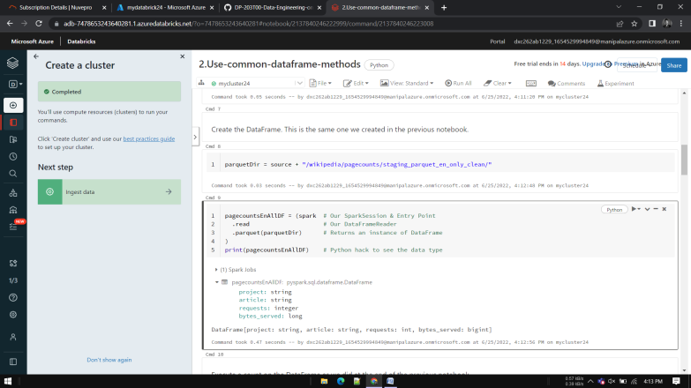

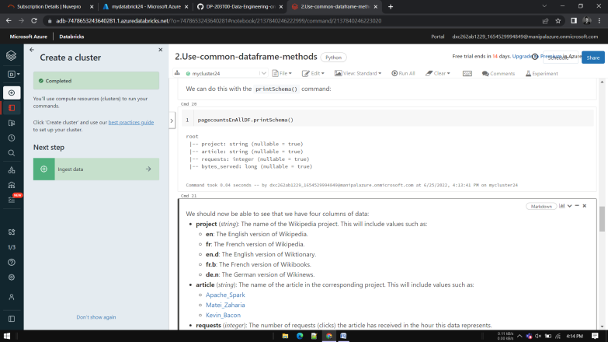

**3. Display Function**

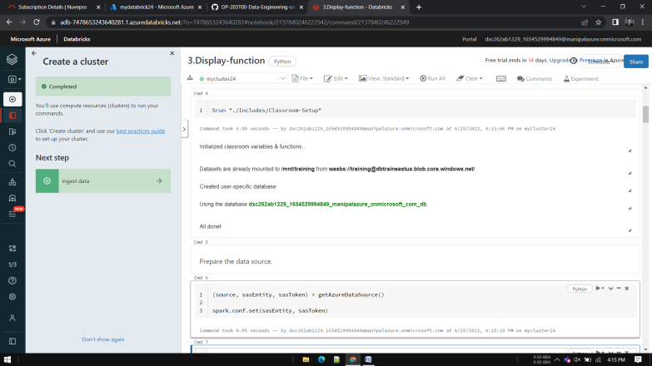

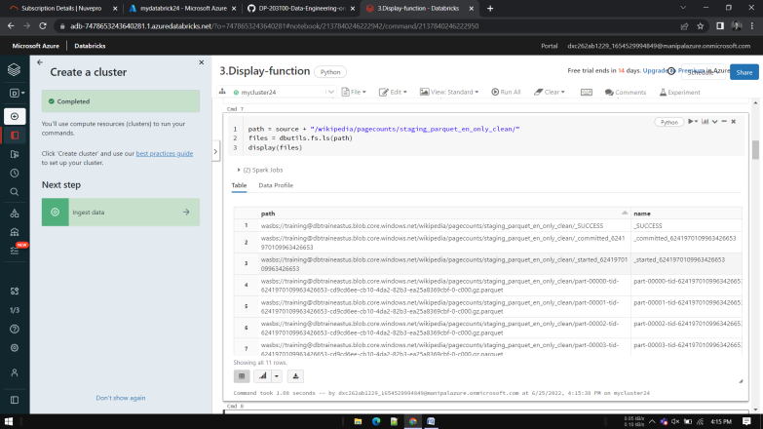

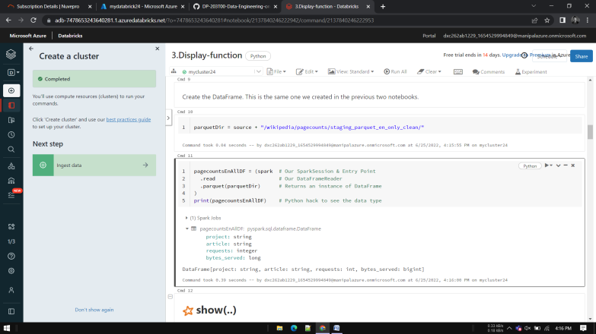

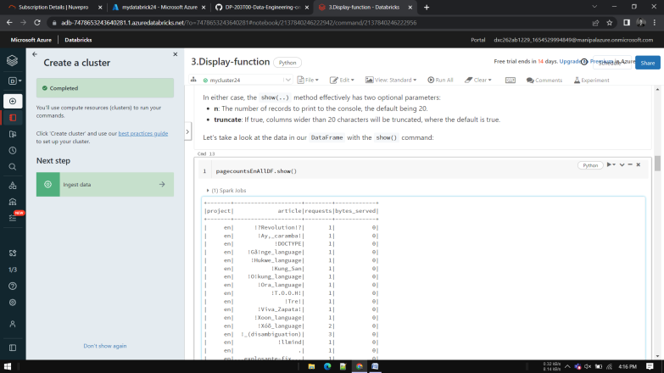

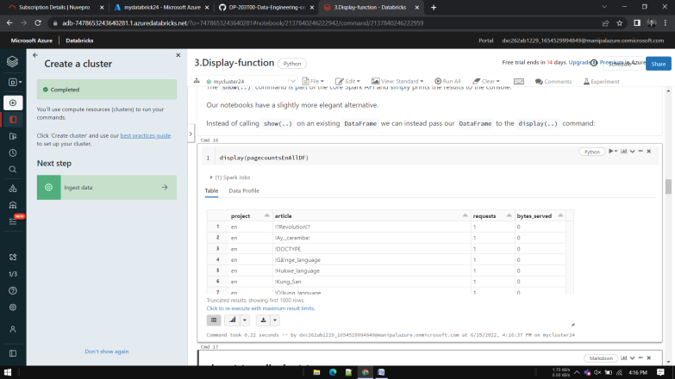

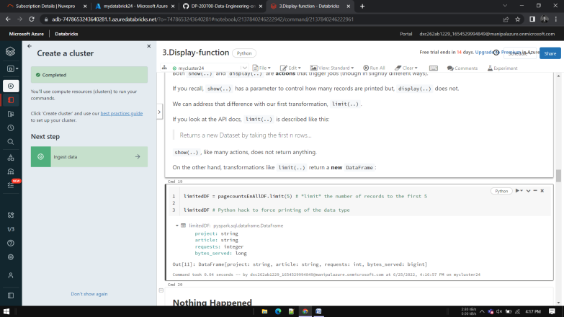

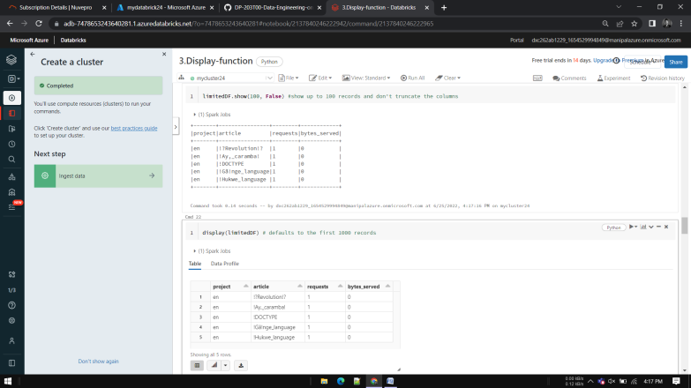

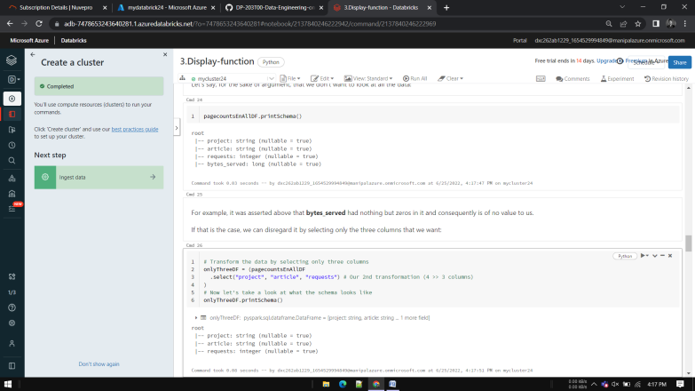

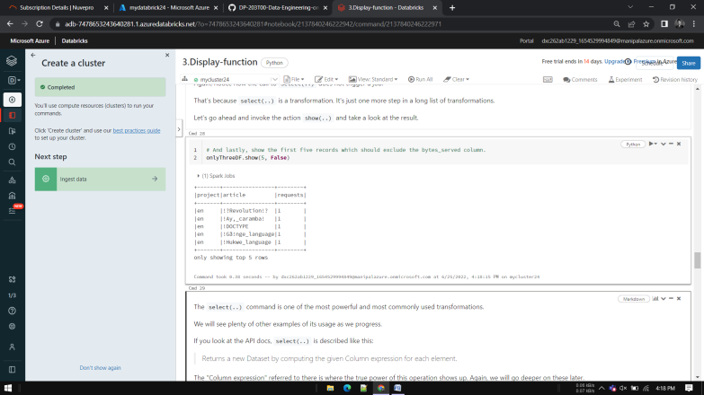

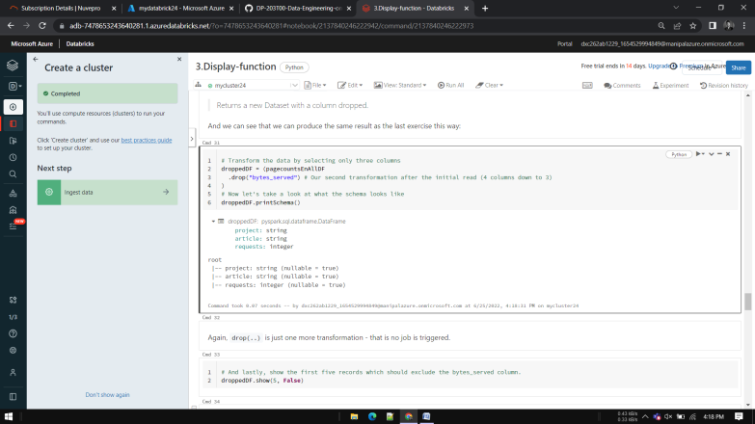

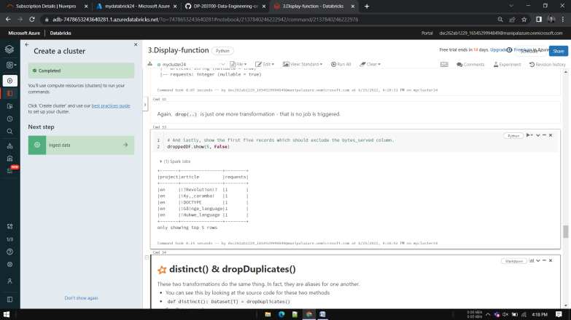

**distinct() & dropDuplicates()**

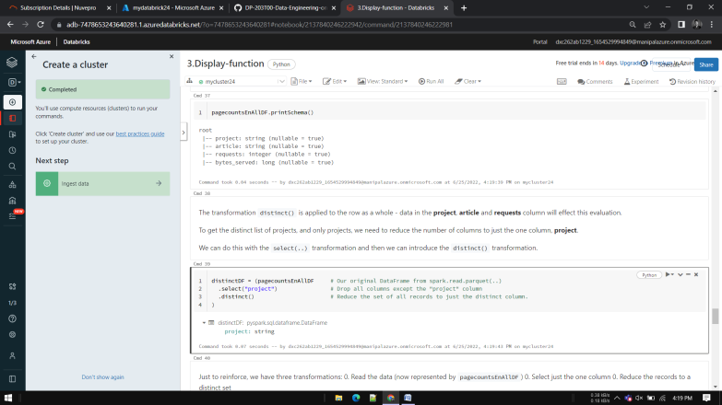

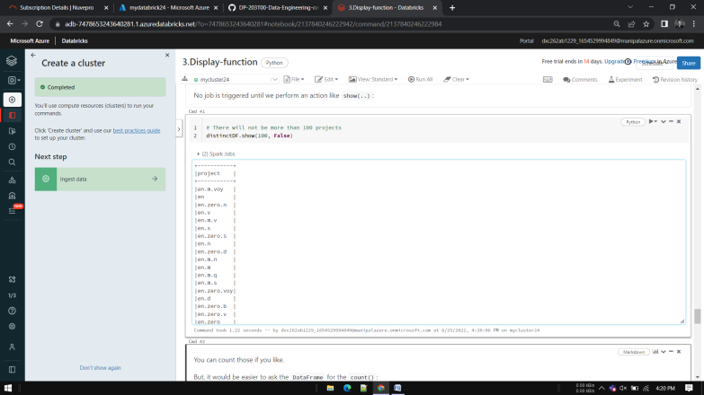

**dropDuplicates(columns...)**

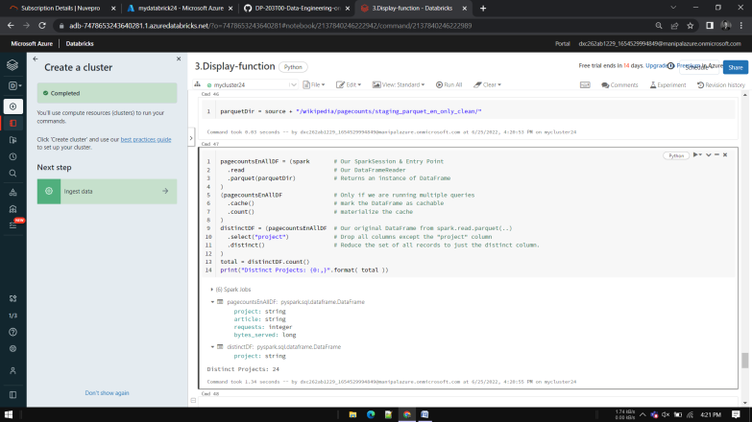

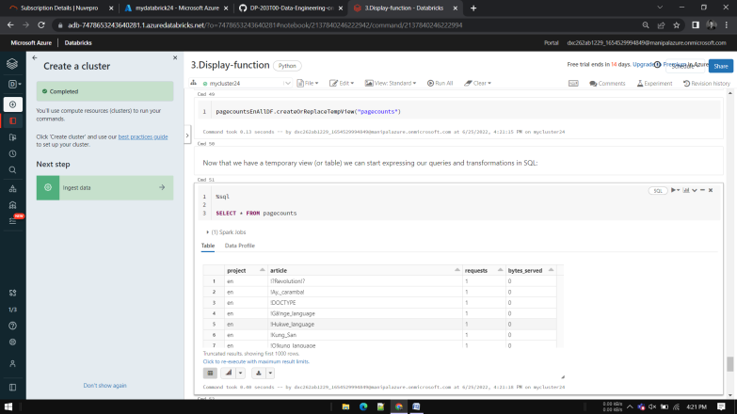

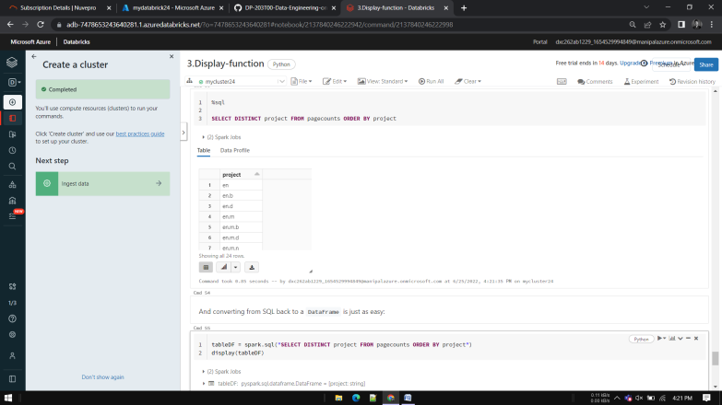

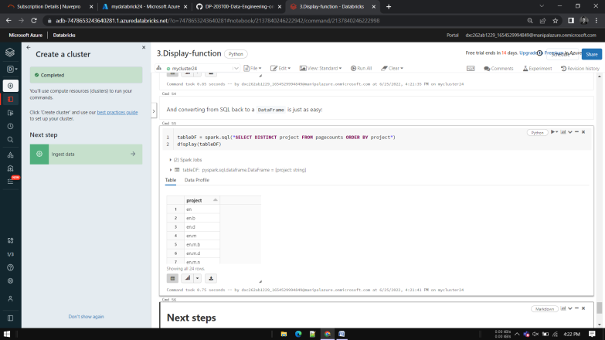

**Exercise 4: Complete the Distinct Articles exercise notebook**

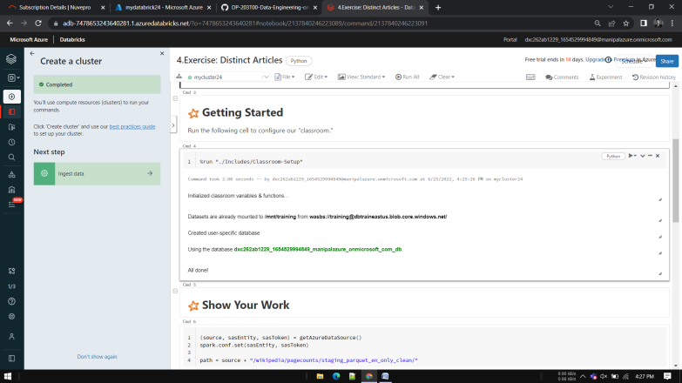

**(source, sasEntity, sasToken) = getAzureDataSource()**

**spark.conf.set(sasEntity, sasToken)**

**path = source + "/wikipedia/pagecounts/staging_parquet_en_only_clean/"**

**# TODO**

**# Replace <<FILL_IN>> with your code.**

**df = (spark # Our SparkSession & Entry Point**

**.read # Our DataFrameReader**

**<<FILL_IN>> # Read in the parquet files**

**<<FILL_IN>> # Reduce the columns to just the one**

**<<FILL_IN>> # Produce a unique set of values**

**)**

**totalArticles = df.<<FILL_IN>> # Identify the total number of records remaining.**

**print("Distinct Articles: {0:,}".format(totalArticles))**

**expected = 1783138**

**assert totalArticles == expected, "Expected the total to be " + str(expected) + " but found " + str(totalArticles)**

**Module 9**

Exercise 0: Start the dedicated SQL pool

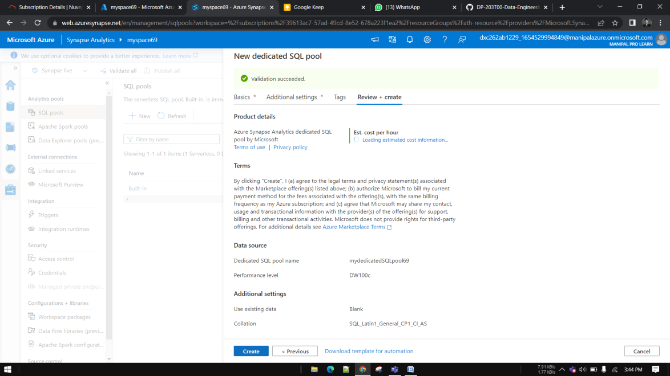

This lab uses the dedicated SQL pool.

As a first step, make sure it is not paused. If so, start it by following these instructions:

Open Synapse Studio (<https://web.azuresynapse.net/>). 2. Select the **Manage** hub. ![The manage hub is highlighted

3. Select **SQL pools** in the left-hand menu

If the dedicated SQL pool is paused, hover over the name of the pool and select **Resume

The resume button is highlighted on the dedicated SQL pool "Resume"

4. When prompted, select **Resume**. It will take a minute or two to resume the pool.

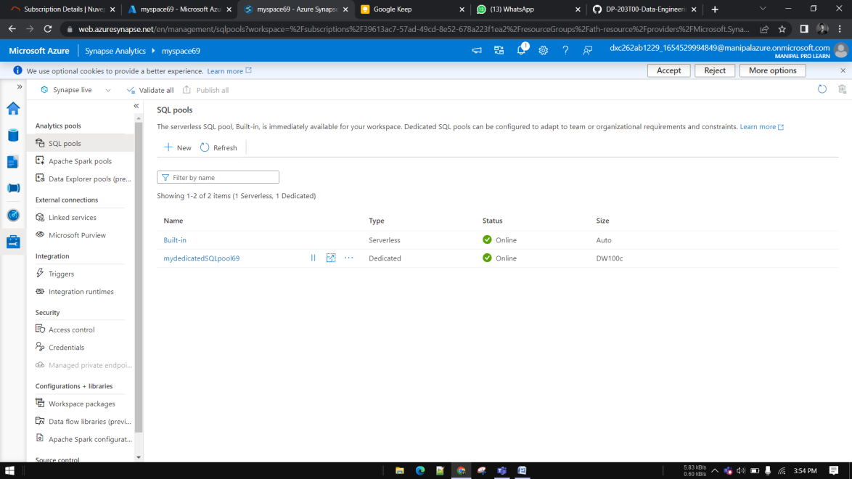

**Module 10 - Optimize query performance with dedicated SQL pools in Azure Synapse**Create dedicated SQL pool in synapse

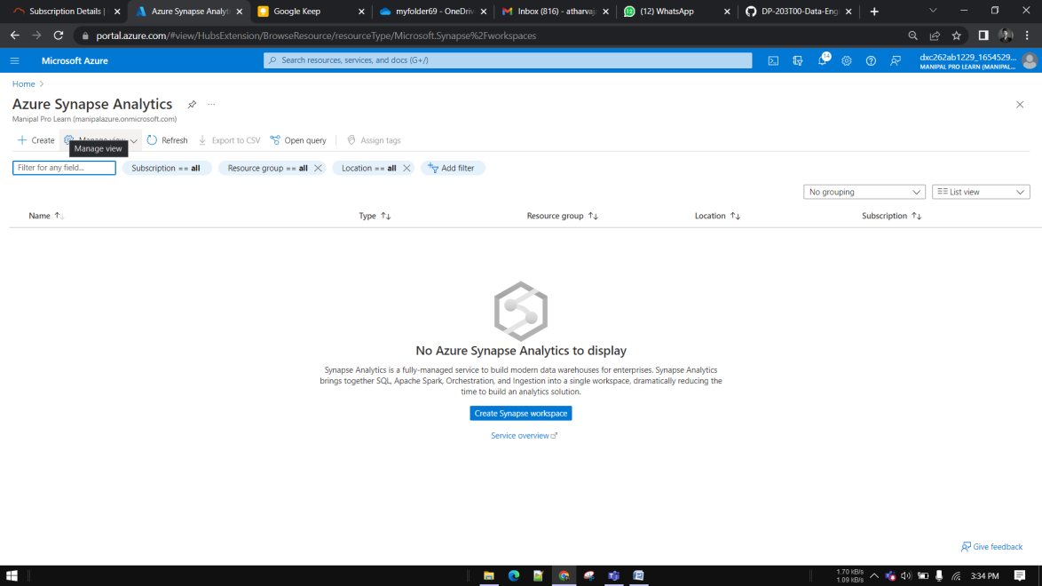

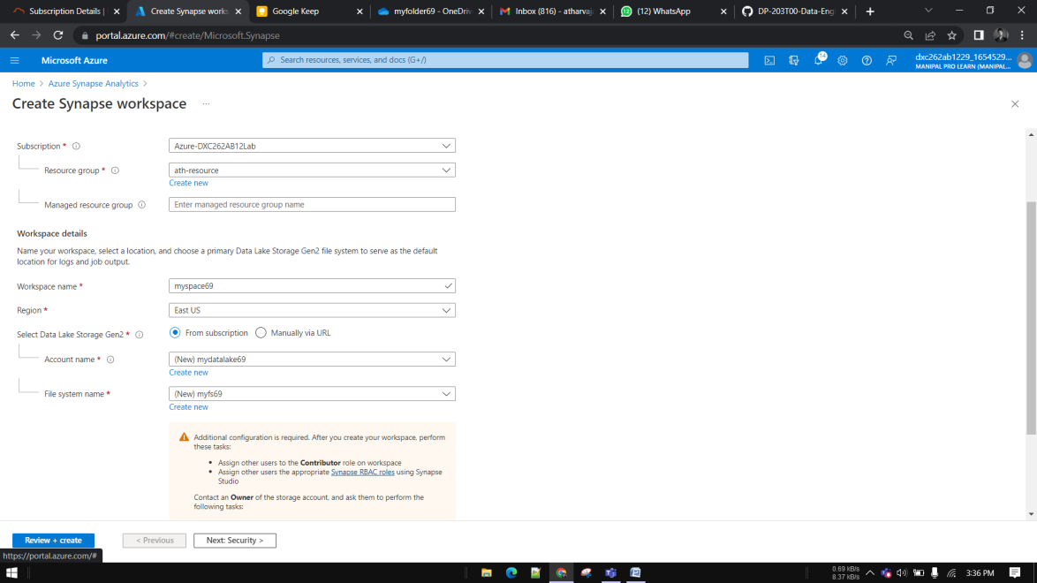

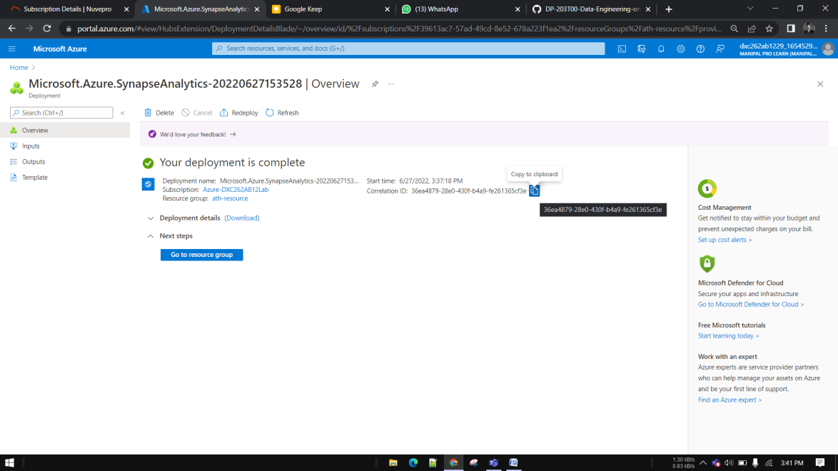

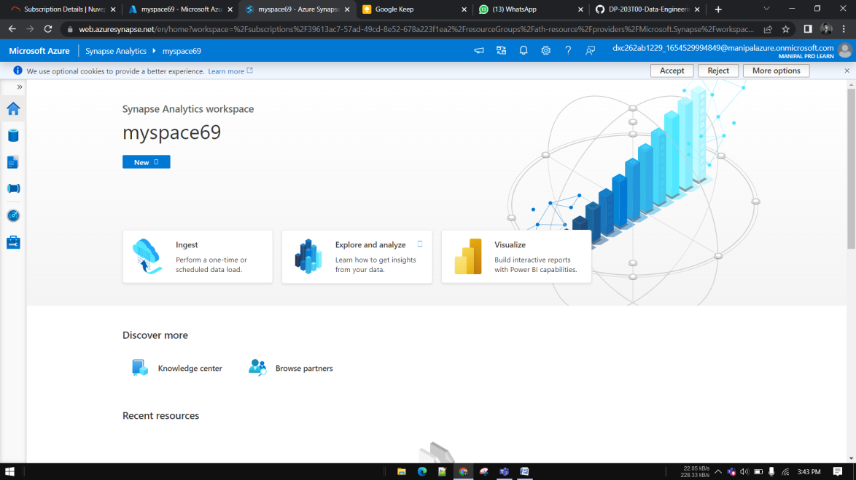

Go to manage – SQL pool- click on +create icon





Go to the Develop hub

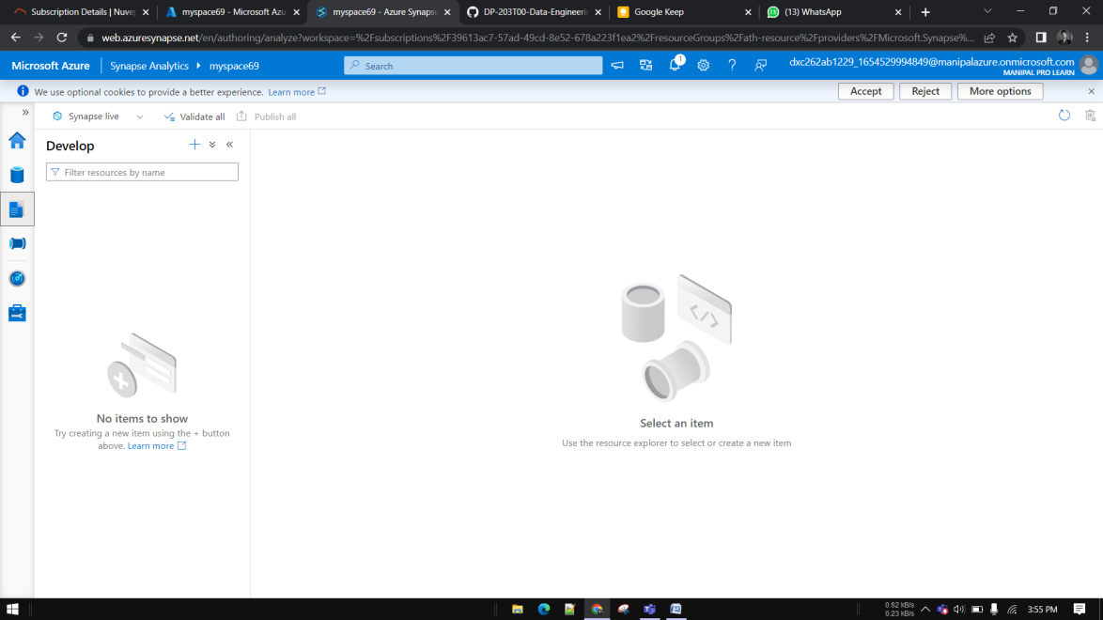

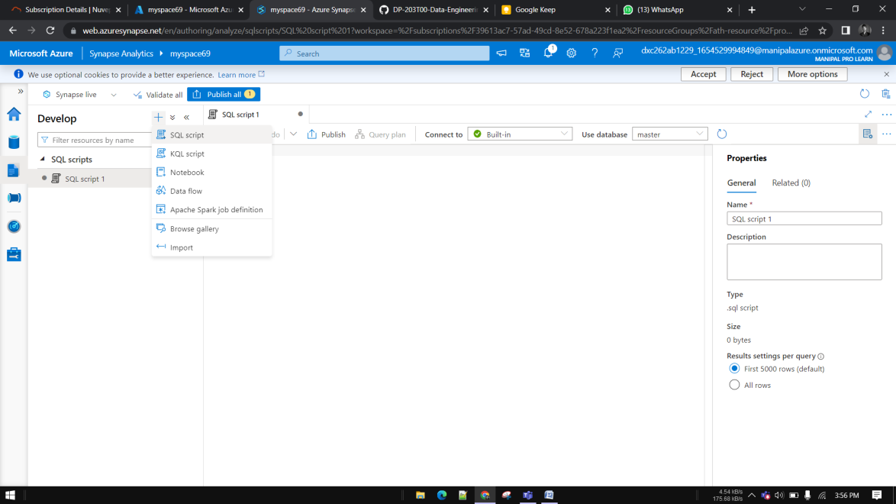

Choose dedicated pool

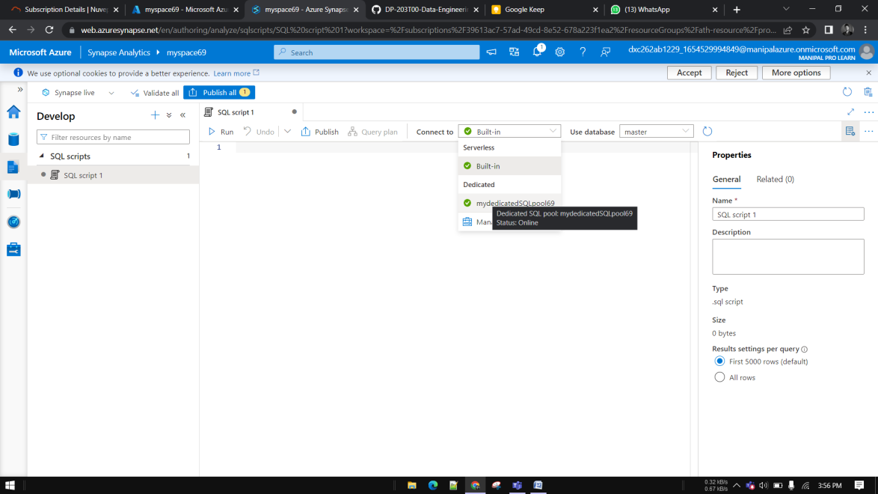

Enter following script

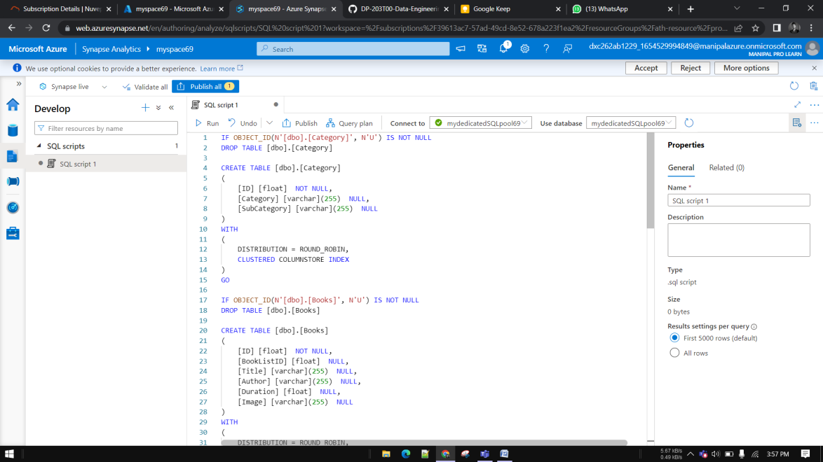

IF OBJECT_ID(N'[dbo].[Category]', N'U') IS NOT NULL  
DROP TABLE [dbo].[Category]  
  
CREATE TABLE [dbo].[Category]  
(   
[ID] [float] NOT NULL,  
[Category] [varchar](255) NULL,  
[SubCategory] [varchar](255) NULL  
)  
WITH  
(  
DISTRIBUTION = ROUND_ROBIN,  
CLUSTERED COLUMNSTORE INDEX  
)  
GO  
  
IF OBJECT_ID(N'[dbo].[Books]', N'U') IS NOT NULL  
DROP TABLE [dbo].[Books]  
  
CREATE TABLE [dbo].[Books]  
(   
[ID] [float] NOT NULL,  
[BookListID] [float] NULL,  
[Title] [varchar](255) NULL,  
[Author] [varchar](255) NULL,  
[Duration] [float] NULL,  
[Image] [varchar](255) NULL  
)  
WITH  
(  
DISTRIBUTION = ROUND_ROBIN,  
CLUSTERED COLUMNSTORE INDEX  
)  
GO  
  
IF OBJECT_ID(N'[dbo].[BookConsumption]', N'U') IS NOT NULL  
DROP TABLE [dbo].[BookConsumption]  
  
CREATE TABLE [dbo].[BookConsumption]  
(   
[BookID] [float] NULL,  
[Clicks] [float] NULL,  
[Downloads] [float] NULL,  
[Time Spent] [float] NULL,  
[Country] [varchar](255) NULL  
)  
WITH  
(  
DISTRIBUTION = ROUND_ROBIN,  
CLUSTERED COLUMNSTORE INDEX  
)  
GO  
  
IF OBJECT_ID(N'[dbo].[BookList]', N'U') IS NOT NULL  
DROP TABLE [dbo].[BookList]  
  
CREATE TABLE [dbo].[BookList]  
(   
[ID] [float] NOT NULL,  
[CategoryID] [float] NULL,  
[BookList] [varchar](255) NULL  
)  
WITH  
(  
DISTRIBUTION = ROUND_ROBIN,  
CLUSTERED COLUMNSTORE INDEX  
)  
GO  
  
COPY INTO Category   
FROM '<https://solliancepublicdata.blob.core.windows.net/dataengineering/dp-203/books/Category.csv'>  
WITH (  
FILE_TYPE = 'CSV',  
FIRSTROW = 2  
)  
GO  
  
COPY INTO Books   
FROM '<https://solliancepublicdata.blob.core.windows.net/dataengineering/dp-203/books/Books.csv'>  
WITH (  
FILE_TYPE = 'CSV',  
FIRSTROW = 2  
)  
GO  
  
COPY INTO BookConsumption   
FROM '<https://solliancepublicdata.blob.core.windows.net/dataengineering/dp-203/books/BookConsumption.csv'>  
WITH (  
FILE_TYPE = 'CSV',  
FIRSTROW = 2  
)  
GO  
  
COPY INTO BookList   
FROM '<https://solliancepublicdata.blob.core.windows.net/dataengineering/dp-203/books/BookList.csv'>  
WITH (  
FILE_TYPE = 'CSV',  
FIRSTROW = 2  
)  
GO

Click on run

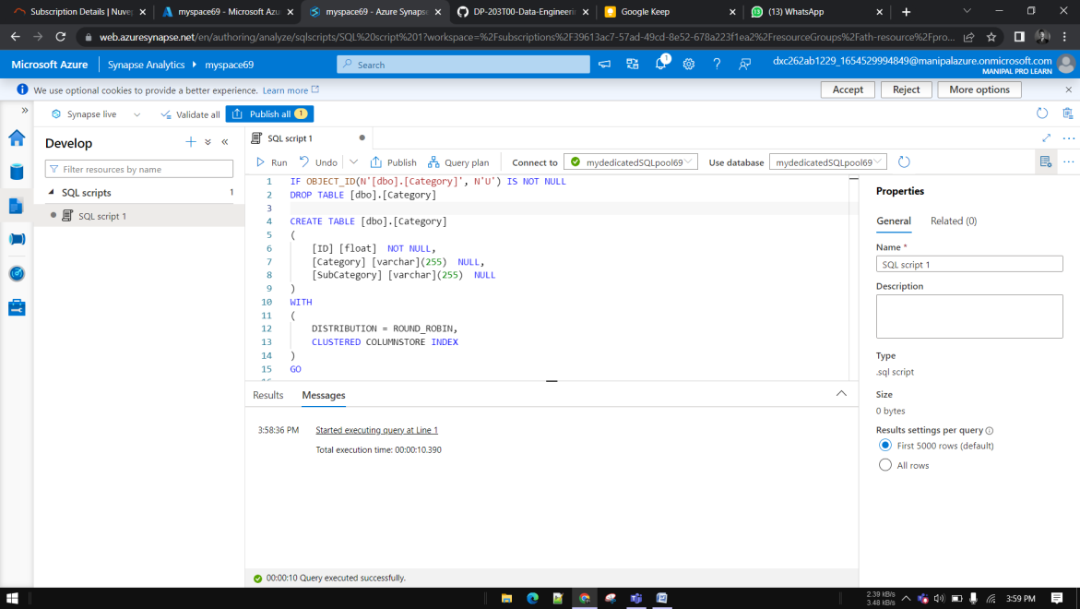

**Module 11 –**

Analyze and optimize Data Warehouse storage









Go to manage – SQL pool- click on +create icon





Go to the Develop hub





Choose dedicated pool



Enter following script

IF OBJECT_ID(N'[wwi_perf].[Sale_Hash]', N'U') IS NULL BEGIN

CREATE TABLE [wwi_perf].[Sale_Hash]

WITH (

DISTRIBUTION = HASH ( [CustomerId] ),

CLUSTERED COLUMNSTORE INDEX )

AS

SELECT * FROM [wwi_poc].[Sale]

END

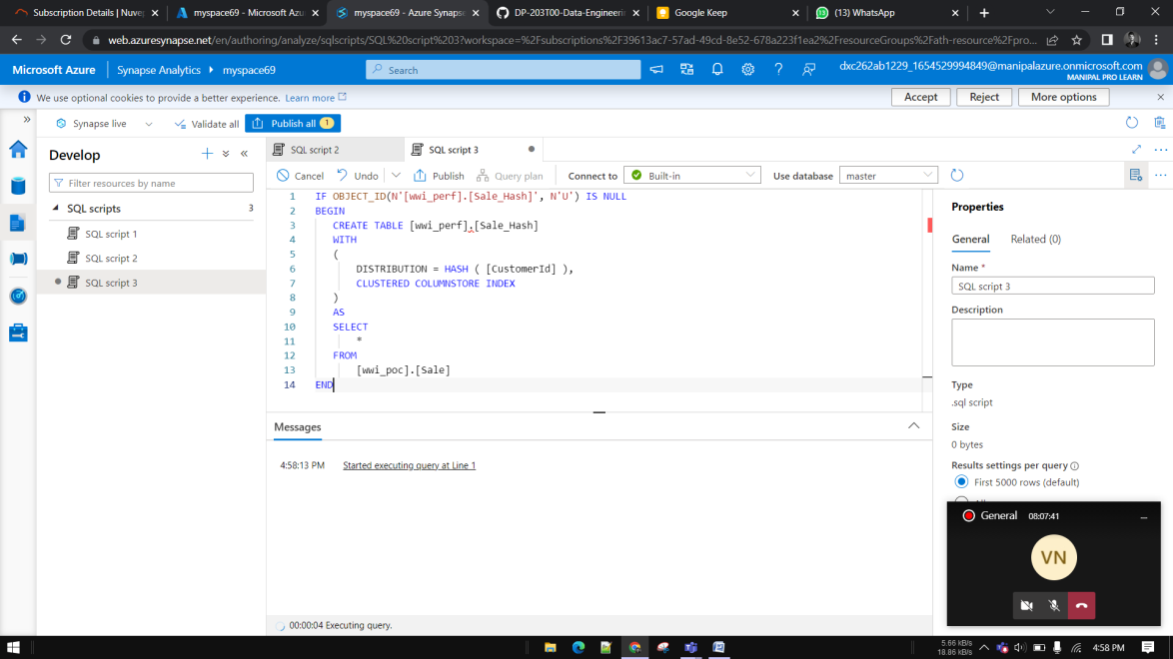

**DBCC PDW_SHOWSPACEUSED('wwi_perf.Sale_Hash');**

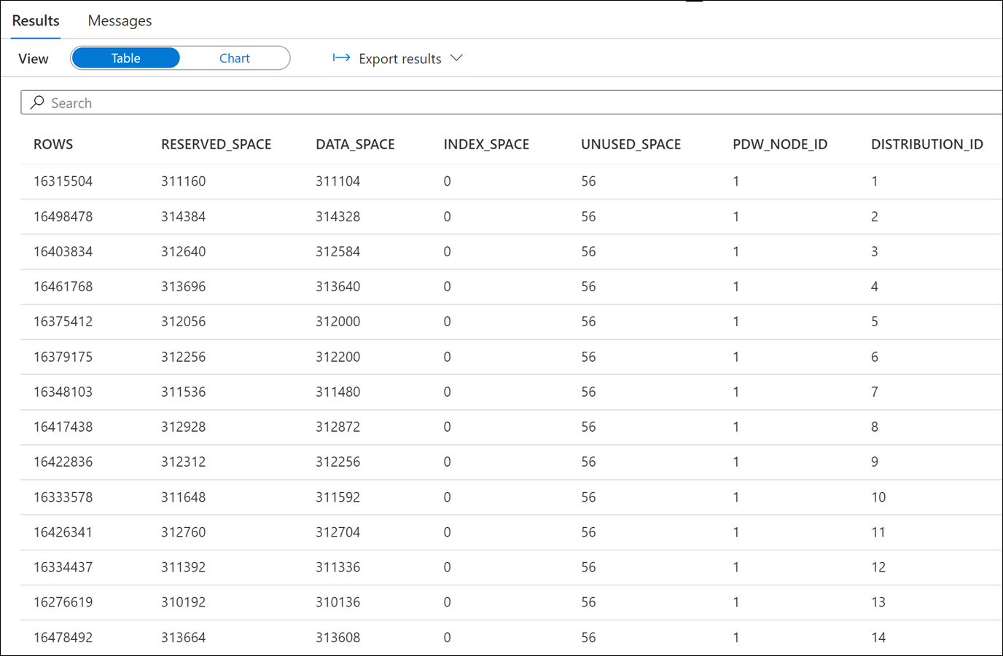

**SELECT TOP 1000**

**CustomerId,**

**count(*) as TransactionItemsCount**

**FROM**

**[wwi_perf].[Sale_Hash]**

**GROUP BY**

**CustomerId**

**ORDER BY**

**count(*) DESC**

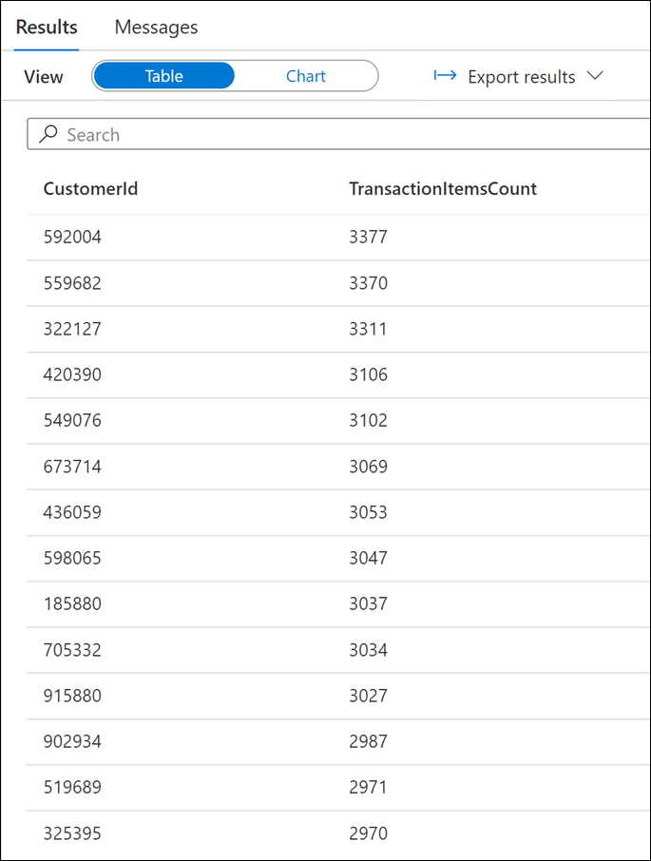

**SELECT TOP 1000**

**CustomerId,**

**count(*) as TransactionItemsCount**

**FROM**

**[wwi_perf].[Sale_Hash]**

**GROUP BY**

**CustomerId**

**ORDER BY**

**count(*) ASC**

